

**COMPUTER NETWORK**

**SECTION 02**

**PROJECT ( TASK 7a)**

**LECTURER : Ms. Hazinah Kutty Mammi**

**GROUP NAME : NetSecret**

**GROUP MEMBERS :**

| **NAME** | **MATRICS NUM** |
| --- | --- |
| PRAVIN SIVANATHAN | A21EC0123 |
| SADIK AL MAHMUD | A20EC4049 |
| ABDUL AZIM BIN ANUAR VEERA | A21EC0001 |
| MOHAMMED HUSSEIN SALEH BA ABBAD | A21EC4015 |

# Abstract

The Faculty of Computing (FC) at UTM University has built a two-story building. The building has 4 new labs: a general purpose lab, a Network lab, an IoT lab, and a Computer Security lab. It also has 2 video conferencing rooms for virtual project meetings and 4 staff rooms (2 on each floor). We now need to set up the network for the building to ensure all devices can connect and communicate with each other.

Our solution needs to be easy to expand and manage. Since the users are already familiar with the system, it's important to provide them with a simple and user-friendly setup. We also want to improve the network's performance and protect it from unauthorized access. Hence, we will go through different steps, like dividing the network into smaller parts and configuring IP addresses(Subnetting) passing by VLANs and DHCP, to make sure FC users, including staff and students, have the best experience and privacy.

To ensure a good project, we need to carefully consider each action we take. Conducting thorough research will help us quickly identify any problems and find alternative solutions to fix them. This way, we can make sure each stage of the project goes well.

**TABLE OF CONTENTS**

**Abstract** **2**

**Introduction** **5**

Task 1 6

1.0 FLOOR PLAN 6

2.0 DESCRIPTION 7

REFLECTION 8

Task 2 9

REFLECTION 9

Task 3 10

1.0 Subnets and Devices addressing 10

REFLECTION 13

Task 4 14

UPDATED TOPOLOGY 14

ROUTE HIGHLIGHTS 15

ROUTING TABLES 16

NEIGHBOR TABLES 19

END-TO- END CONNECTION 20

REFLECTION 21

Task 5 22

1.0 Updated Subnets and Devices addressing 22

2.0 VLAN TABLE 27

REFLECTION 37

Task 6 38

CONFIGURATIONS ON IMPLEMENTING DHCPV4 SERVER 38

CONFIGURING THE RELAY AGENT 41

DHCP REQUEST 43

REFLECTION 45

**Conclusion** **46**

**Team responsibilities** **47**

**TABLE OF FIGURES**

**2**

**Introduction** **7**

Task 18

Figure 1.0 shows first floor 8

Figure 1.1 shows first floor10

Task 2 11

Figure 2.0 shows the updated topology15

Task 416

Figure 4.1 shows updated topology17

ROUTING TABLES 18

Figure 4.3.1 shows routing table of RTA 18

Figure 4.3.2 shows routing table of RTB 18

Figure 4.3.3 shows routing table of RTC 19

Figure 4.3.4 shows routing table of RTD 19

Figure 4.3.5 shows routing table of RTE 20

Figure 4.3.6 shows routing table of RTF 20

NEIGHBOR TABLES 21

Figure 4.4.1 shows neighbor table of RTA 21

Figure 4.4.2 shows neighbor table of RTB 21

Figure 4.4.3 shows neighbor table of RTC 21

Figure 4.4.4 shows neighbor table of RTD 22

Figure 4.4.5 shows neighbor table of RTE 22

Figure 4.4.6 shows neighbor table of RTF 22

END-TO- END CONNECTION 23

Figure 4.5.1 shows end-to-end connection from Computer Security Lab LAN to Video Conferencing Room 2 LAN 23

Figure 4.5.2 shows end-to-end connection from Video Conferencing Room LAN 2 to General Purpose Lab LAN 23

Figure 4.5.3 shows end-to-end connection from General Purpose Lab LAN to Network Lab LAN 24

Figure 4.5.4 shows end-to-end connection from RTC to ISP (UTM Backbone)25

Task 526

2.0 VLAN TABLE 31

Figure 5.2 shows updated topology 31

Figure 5.2.1 shows VC2 switch 32

● VC1 Switch 32

Figure 5.2.2 shows VC1 switch 32

● Network Lab SwitchFigure 5.2.3 shows Network Lab Switch 33

● IoT Lab Switch Figure 5.2.4 shows IoT Lab Switch 33

Figure 5.2.5 shows General Purpose Lab Switch 34

Figure 5.2.6 shows Computer Security Lab 34

Figure 5.2.7 shows routing table of RTA 35

Figure 5.2.8 shows routing table of RTB 36

Figure 5.2.10 shows routing table of RTD 38

Figure 5.2.11 shows routing table of RTE 39

Figure 5.2.12 shows routing table of RTF 40 41

Task 6 42

Figure 6.1 shows updated topology 42

CONFIGURATIONS ON IMPLEMENTING DHCPV4 SERVER 43

Figure 6.1.1 shows configuration on Network Lab 43

Figure 6.1.2 shows configuration on IoT Lab 43

Figure 6.1.3 shows configuration on VCI and SRF2 43

Figure 6.1.4 shows configuration on General Lab 44

Figure 6.1.5 shows configuration on Computer Securiy Lab 44

Figure 6.1.6 shows configuration on VC2 and SRF1 44

CONFIGURING THE RELAT AGENT 45

Figure 6.2.1 shows configuration on RTA 45

Figure 6.2.2 shows configuration on RTB 45

Figure 6.2.3 shows configuration on RTC 45

Figure 6.2.4 shows configuration on RTF 46

Figure 6.2.5 shows configuration on RTE 46

DHCP REQUEST 47

Figure 6.3.1.1 shows DHCP request on VC2_PC1-2 47

Figure 6.3.1.1 shows DHCP request on SR1_PC1 47

Figure 6.3.2.1 shows DHCP request on VC2_PC4-1 48

Figure 6.3.1.1 shows DHCP request on SR4_PC3**51**

# Introduction

This is a group project where we apply what we learned in class to a simulation app called Packet Tracer. The goal is to build a small network with all the necessary components, configurations, and protocols. We need to understand the needs of the users or customers and design a network infrastructure to meet their current and future requirements. We also need to research and use available network devices, calculate and do subnetting for IP addresses, and present our work to the customer. The project consists of 7 tasks that must be completed within the given time.

Task 1 involves the updated layout of a two-floor building with various labs and facilities. In Task 2, we use the Packet Tracer app to implement the layout and connect the labs with a complete network using appropriate devices and cables. Task 3 focuses on subnetting, where we divide the subnets for each lab based on given IP addresses and variable size subnetting.

For Task 4, we connect the different subnets to ensure end-to-end connectivity. We use a combination of static and dynamic routing protocols to achieve this, using static routing for some routers and EIGRP dynamic routing for others. This ensures availability even if one router fails.

Task 5 requires us to create separate VLANs for each room/lab to ensure privacy and authentication. Each lab will have different VLANs with different access levels. In Task 6, we implement DHCP to assign IP addresses and default gateways to devices automatically, saving time and avoiding duplicate IP addresses.

Finally, in Task 7, we should complete the group report to evaluate our work and provide suggestions for improvement. The report follows a guideline and should provide a clear overview of our work, including reflections and recommendations.

## Task 1

### **1.0 FLOOR PLAN**

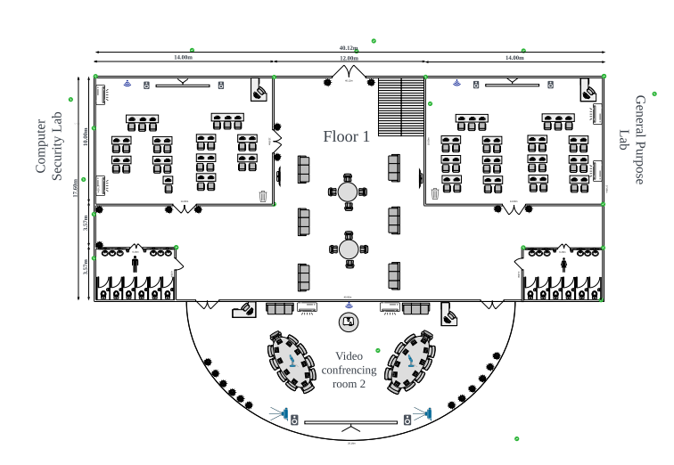

#### Figure 1.0 shows first floor

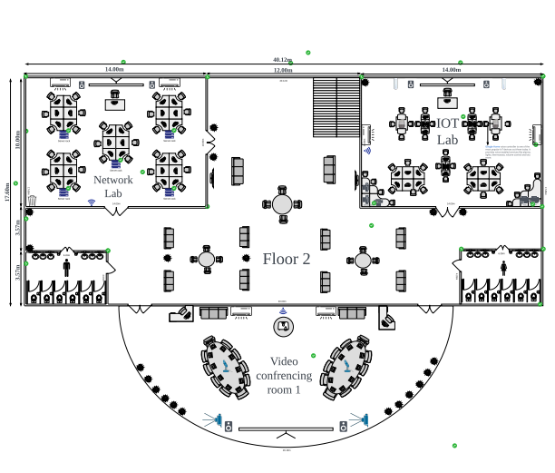

#### Figure 1.1 shows first floor

### 2.0 DESCRIPTION

**GENERAL PURPOSE LAB**

As we can see, we also have included one general purpose lab that could be used by everyone. In

this general purpose lab we are installing 31 workstations where students can comfortably learn

and educate themselves. This general purpose lab could be used to conduct classes,

presentations, doing group works and many more. We are also providing this room with network

connection to make the learning environment much more convenient

**COMPUTER SECURITY LAB**

We are trying to provide vast practical knowledge to the computer security (Cyber security)

students to get hands-on in penetration testing, cryptography, and more. Believing that this lab

can act in such a way, we are installing 25 workstations with Linux OS. Additionally, we are

providing Virtual Box where students will have the experiences exploring multiple OSes.

**NETWORK LAB**

Students get to explore the network devices while their lab session in this network lab. Here, we

are providing racks of switches and routers which are connected to workstations. Students tend

to learn fundamentals of networks such as configurations of switches and routers. Here, we are

providing 32 workstations altogether for students to carry out their lessons. We are also letting

the students to gain knowledge about physical connectivities as there would be multiple type of

physical media available in the lab such as UTP cable, fiber optic cable and etc.

**IOT LAB**

Exposing Science Computer students to IOT devices is the purpose for the lab to get developed

in our project. In the lab, we included IOT related devices such as 3D printers,Foobot, Google

Home, and smart air-cons. We are placing 25 workstations in the lab for students to carry out

their studies. Foobot is an IOT device that can accurately measure indoor air pollution index

(API) which can help in improving the air quality of the lab. Google home is a voice controller

Iot device which can be featured in timer, weather forecast, alarm, speaker’s volume controller

and etc. Apart from this, Iot devices such as smart light, smart window, light/sound sensors

which can trigger windows and projector are also suited in the lab.

**VIDEO CONFERENCING ROOM**

We have a video conferencing room which will be used mostly for important meetings for the

lecturers, VIPs and student committees. This room will be equipped with 2 workstations that will

be used for presentations and many other meeting related activities. We are also installing certain

IOT devices in this room as it will be more professional and make the presentations and meetings

much convenient. IOT devices we are installing are such as smart projector and smart screen.

This room also will be built to be soundproof to uphold the privacy in the room and make the

environment in the room controlled during a meeting

### REFLECTION

In this task, we had to choose a floor plan of one of the team mates’ floorplan used in their previous Computer Networking project which was then altered according to our current project requirement. Placements of each individual lab and other rooms were well planned based on criterias such as students’ convenience, cost, and so on. We also had specified usage of each lab and video conferencing rooms. We could do this better if we were aware about future tasks such as implementing VLANs. This is so because, when dividing the subnet further for VLAN implementation the configurations became a little bit harder as the placements of the hosts and labs aren’t compatible for that.

## Task 2

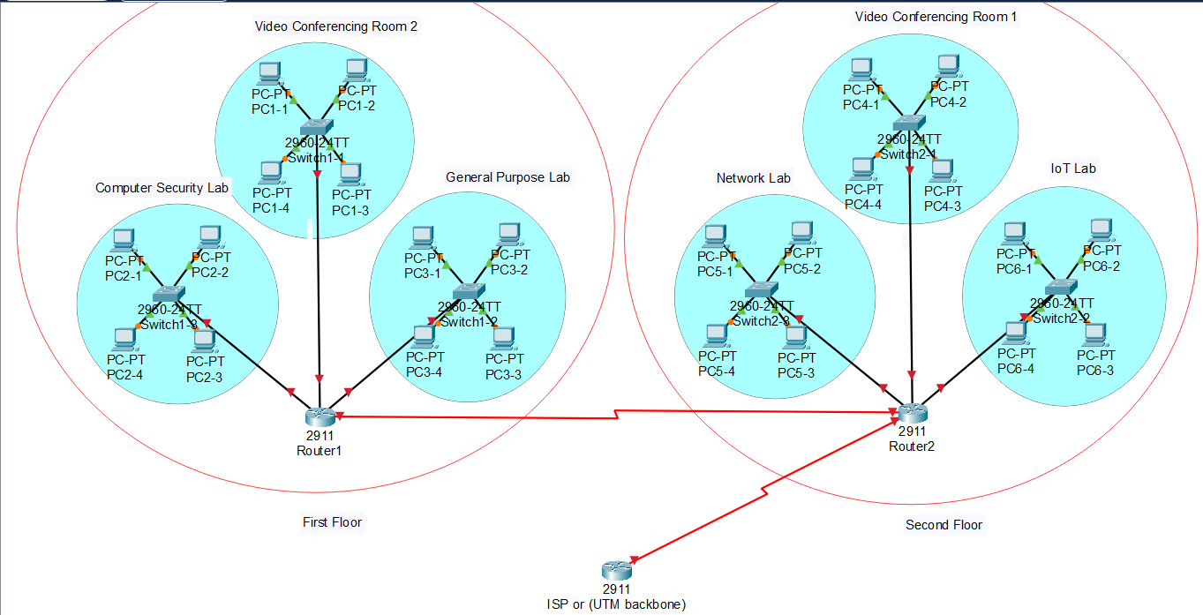

#### Figure 2.0 shows the updated topology

### REFLECTION

In this task, we designed a network topology based on the floor plan that was designed previously on task 1. We placed a router in each floor due to cost-cutting reasons and also one router more to connect to the ISP. With knowledge about VLANs and routing algorithms we could do the topology even better.

## Task 3

### 1.0 Subnets and Devices addressing

As we have the assigned IP address which is 172.16.32.0/23, in this report we will be showing how we divided the subnets for each room/lab and the workings as well.

**Step 1 (Dividing portions):**

172.16.00100000.00000000  
Network portion - Host portion

**Step2 (Borrow bits):**

Network lab: 2x = 32, x = 6 bits (Since 32 addresses are not enough because we still need 2 address for network address and broadcast address)

General purpose lab: 2x = 31, x = 6 bits,

Computer Security lab: 2x = 25, x = 5 bits.

IOT lab: 2x = 25, x = 5 bits.

VC1: 2 hosts, 2x = 4, x = 3 bits.

VC2: 2 hosts, 2x = 4, x = 3 bits.

RTA-RTB: 2 hosts, 2x = 4, x = 2 bits.

RTC-RTB: 2 hosts, 2x = 4, x = 2 bits.

RTB-RTF: 2 hosts, 2x = 4, x = 2 bits.

RTB-ISP: 2 hosts, 2x = 4, x = 2 bits.

RTF-ISP: 2 hosts, 2x = 4, x = 2 bits.

RTF-RTD: 2 hosts, 2x = 4, x = 2 bits.

RTF-RTE: 2 hosts, 2x = 4, x = 2 bits.

**Step 3 (Borrow bits):**

S#0 (Network Lab):  
172.16.00100000.00000000 [32.0] NA  
172.16.00100000.00111111 [32.63] BA

S#1 (General Purpose lab):  
172.16.00100000.01000000 [32.64] NA  
172.16.00100000.01111111 [32.127] BA

S#2 (Computer Security Lab):  
172.16.00100000.10000000 [32.128] NA  
172.16.00100000.10011111 [32.159] BA

S#3 (IOT Lab):  
172.16.00100000.10100000 [32.160] NA  
172.16.00100000.10111111 [32.191] BA

S#4 (VC1):  
172.16.00100000.11000000 [32.192] NA  
172.16.00100000.11000111 [32.199] BA

S#5 (VC2):  
172.16.00100000.11001000 [32.200] NA  
172.16.00100000.11001111 [32.207] BA  
  
S#6 (RTA-RTB):  
172.16.00100000.11010000 [32.208] NA  
172.16.00100000.11010011 [32.211] BA

S#7 (RTC-RTB):  
172.16.00100000.11010100 [32.212] NA  
172.16.00100000.11010111 [32.215] BA

S#8 (RTB-RTF):  
172.16.00100000.11011000 [32.216] NA  
172.16.00100000.11011011 [32.219] BA

S#9 (RTB-ISP):  
172.16.00100000.11011100 [32.220] NA  
172.16.00100000.11011111 [32.223] BA

S#10 (RTF-ISP):  
172.16.00100000.11100000 [32.224] NA  
172.16.00100000.11100011 [32.227] BA

S#11 (RTF-RTD):  
172.16.00100000.11100100 [32.228] NA  
172.16.00100000.11100111 [32.231] BAS#12 (RTF-RTE):  
172.16.00100000.11101000 [32.232] NA  
172.16.00100000.11101011 [32.235] BA

| SUBNET | NETWORK ADDRESS | BROADCAST ADDRESS | USABLE ADD. RANGE | NUMBER OF USABLE IP ADDRESSES | SUBNET MASK |
| --- | --- | --- | --- | --- | --- |
| 0 | 172.16.32.0 | 172.16.32.63 | 172.16.32.1 - 172.16.32.62 | 62 | 255.255.255.192 |
| 1 | 172.16.32.64 | 172.16.32.127 | 172.16.32.65 - 172.16.32.126 | 62 | 255.255.255.192 |
| 2 | 172.16.32.128 | 172.16.32.159 | 172.16.32.129 - 172.16.32.158 | 30 | 255.255.255.224 |
| 3 | 172.16.32.160 | 172.16.32.191 | 172.16.32.161 - 172.16.32.190 | 30 | 255.255.255.224 |
| 4 | 172.16.32.192 | 172.16.32.199 | 172.16.32.193 - 172.16.32.198 | 6 | 255.255.255.248 |
| 5 | 172.16.32.200 | 172.16.32.207 | 172.16.32.201 - 172.16.32.206 | 6 | 255.255.255.248 |
| 6 | 172.16.32.208 | 172.16.32.211 | 172.16.32.209 - 172.16.32.210 | 2 | 255.255.255.252 |
| 7 | 172.16.32.212 | 172.16.32.215 | 172.16.32.213 - 172.16.32.214 | 2 | 255.255.255.252 |
| 8 | 172.16.32.216 | 172.16.32.219 | 172.16.32.217 - 172.16.32.218 | 2 | 255.255.255.252 |
| 9 | 172.16.32.220 | 172.16.32.223 | 172.16.32.221 - 172.16.32.222 | 2 | 255.255.255.252 |
| 10 | 172.16.32.224 | 172.16.32.227 | 172.16.32.225 - 172.16.32.226 | 2 | 255.255.255.252 |
| 11 | 172.16.32.228 | 172.16.32.231 | 172.16.32.229 - 172.16.32.230 | 2 | 255.255.255.252 |
| 12 | 172.16.32.232 | 172.16.32.235 | 172.16.32.233 - 172.16.32.234 | 2 | 255.255.255.252 |

### REFLECTION

In task 3, we were subnetting using the given network address. We were up to 12 subnettings based on the network topology. We did the calculations for the subnetting in order to get the network and broadcast address as well as IP address range clearly. Since, the number of hosts for each lab and VC room we had to do subnetting according to the individual room’s hosts number. We were concerned about IP address wastage which made us plan properly to allocate hosts in the rooms in order to allocate as few IP addresses in a subnet as we can.

## Task 4

### UPDATED TOPOLOGY

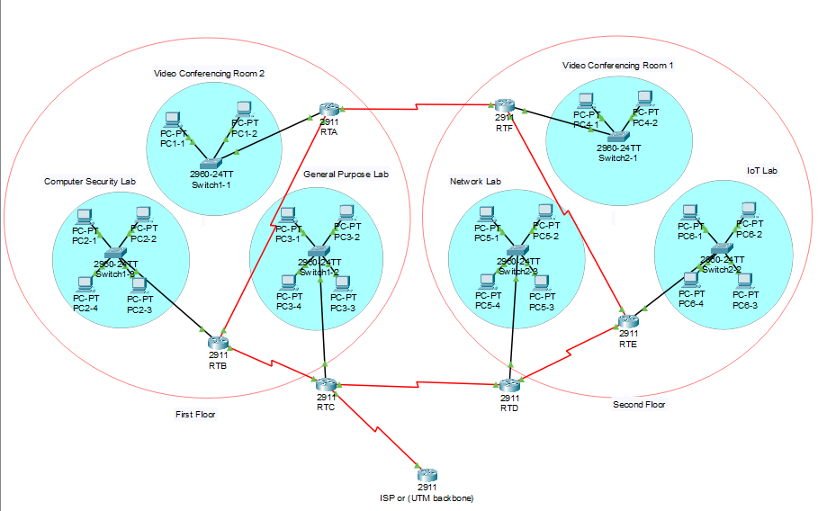

#### Figure 4.1 shows updated topology

**Justification on updating the topology**

Previously, our group used only one router on each floor. Using The topology it is not possible to show multiple routing protocols. In order to overcome the problem, we came with this new topology. Here, we have one router for every room which is a total of 7 routers (6 routers + 1 for ISP). Providing a router for each lan increases efficiency of our network.

### ROUTE HIGHLIGHTS

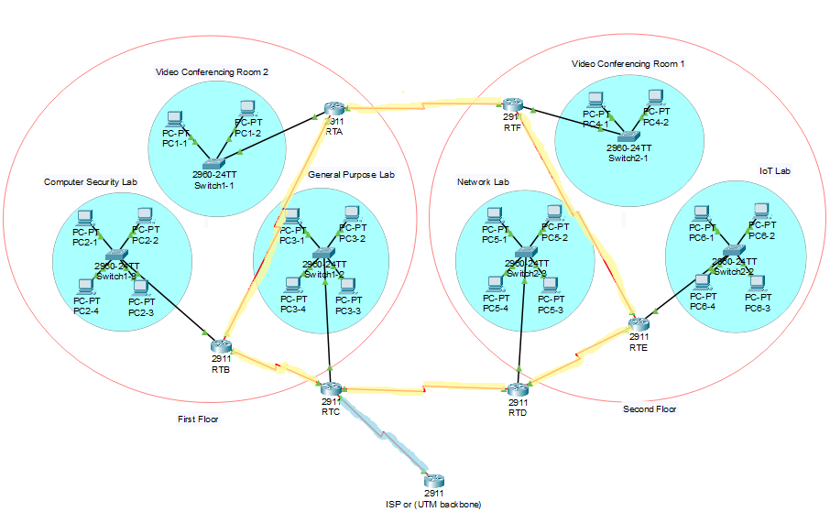

Figure 4.2 shows highlighted topology

Routes that are highlighted in orange in figure 2.0 are dynamic routes. Basically, in our topology routers that are inside the building (first floor and second floor) use dynamic routing. In detail, Route from RTA to RTB, RTB to RTC, RTC to RTD, RTD to RTE, RTE to RTF and RTF to RTA. These routes are using dynamic routing. Furthermore, these routes are using Enhanced Interway Gateway Routing Protocol (EIGRP) with an AS of 1.

Whereas, the router that connected outside of the building which is an ISP router was connected statically to RTC. This route highlighted in blue in the figure 2.0

### ROUTING TABLES

**RTA:**

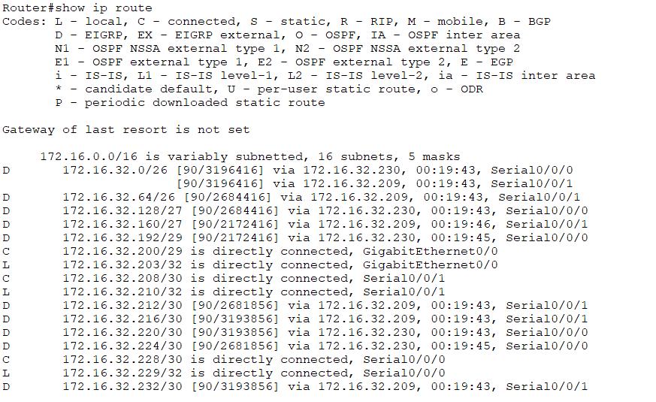

#### Figure 4.3.1 shows routing table of RTA

**RTB:**

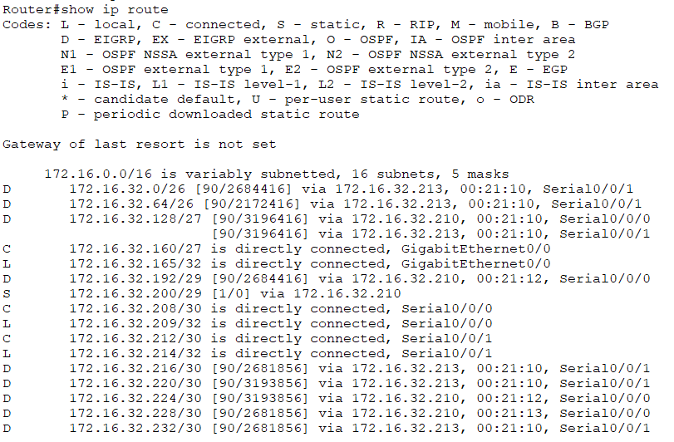

#### Figure 4.3.2 shows routing table of RTB

**RTC:**

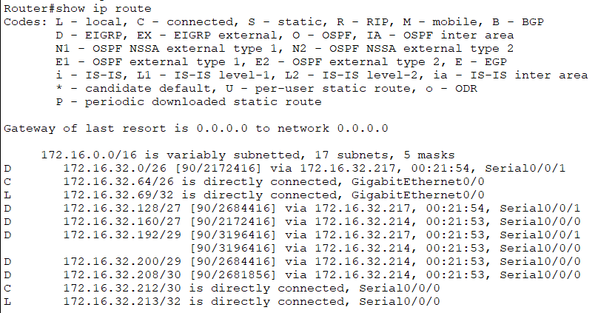

#### Figure 4.3.3 shows routing table of RTC

**RTD**

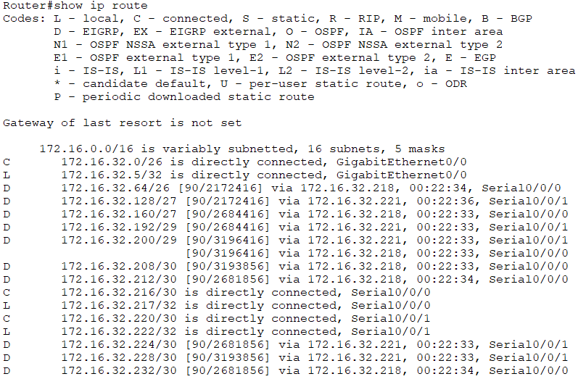

#### Figure 4.3.4 shows routing table of RTD

**RTE**

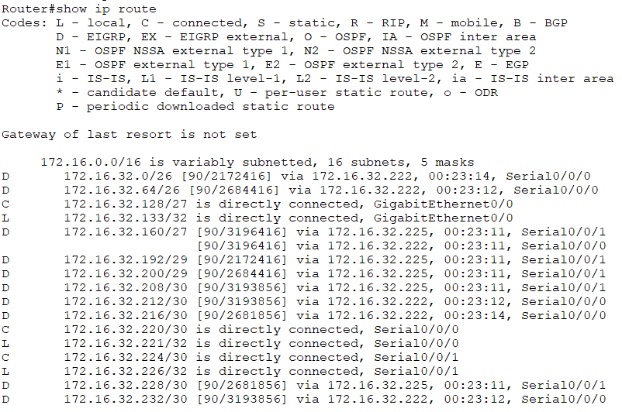

#### Figure 4.3.5 shows routing table of RTE

**RTF**

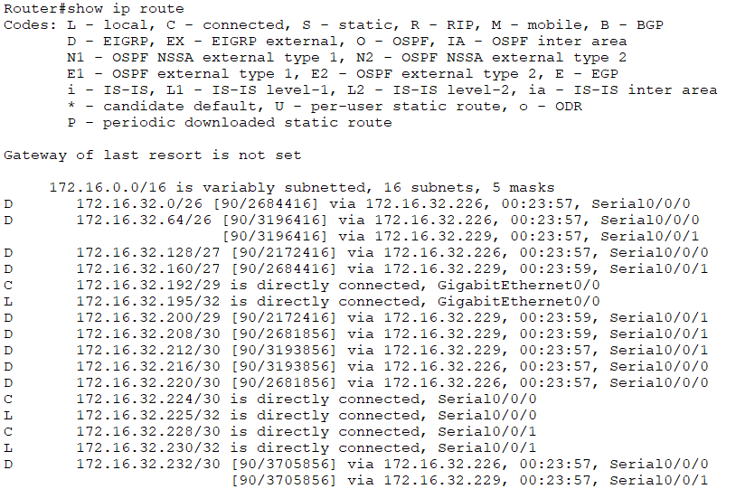

#### Figure 4.3.6 shows routing table of RTF

### NEIGHBOUR TABLES

To show EIGRP routing configuration

**RTA**

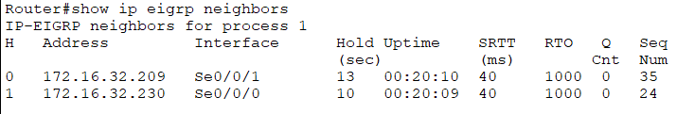

#### Figure 4.4.1 shows neighbour table of RTA

**RTB**

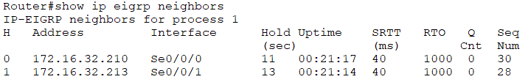

#### Figure 4.4.2 shows neighbour table of RTB

**RTC**

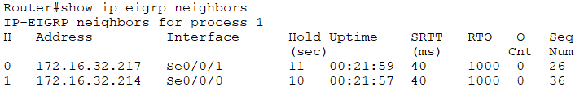

#### Figure 4.4.3 shows neighbour table of RTC

**RTD**

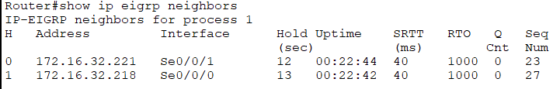

#### Figure 4.4.4 shows neighbour table of RTD

**RTE**

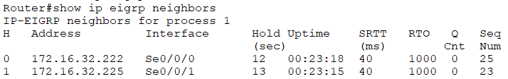

#### Figure 4.4.5 shows neighbour table of RTE

**RTF**

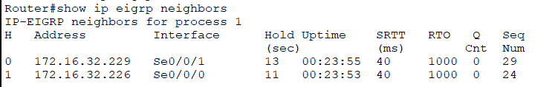

#### Figure 4.4.6 shows neighbour table of RTF

### END-TO- END CONNECTION

**1. From Computer Security Lab LAN to Video Conferencing Room 2 LAN**

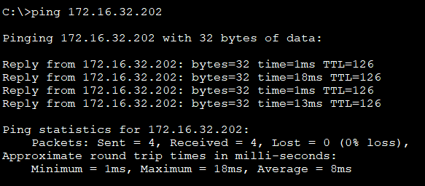

#### Figure 4.5.1 shows end-to-end connection from Computer Security Lab LAN to Video Conferencing Room 2 LAN

**2. From Video Conferencing Room LAN 2 to General Purpose Lab LAN**

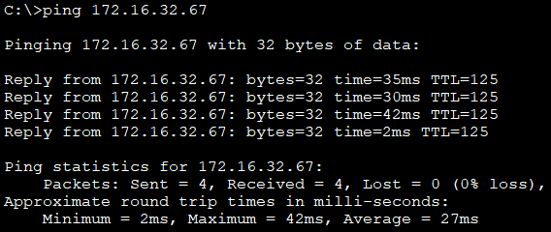

#### Figure 4.5.2 shows end-to-end connection from Video Conferencing Room LAN 2 to General Purpose Lab LAN

**3. From General Purpose Lab LAN to Network Lab LAN**

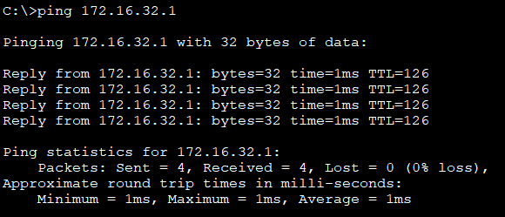

#### Figure 4.5.3 shows end-to-end connection from General Purpose Lab LAN to Network Lab LAN

**4. From RTC to ISP (UTM Backbone)**

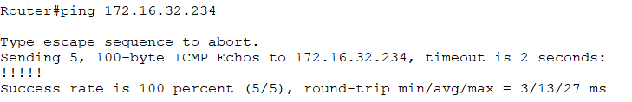

#### Figure 4.5.4 shows end-to-end connection from RTC to ISP (UTM Backbone)

### 

### 

### 

### 

### 

### 

### REFLECTION

In this task, we implemented a dynamic routing algorithm in our network for end-to-end host communication. We used EIGRP routing protocol in our network. Assigning each and every network its network address was done in this task. Also we gave the end hosts an IP address which were subnetted in the previous task. Lastly, we have ensured that every end to end host can communicate with each other regardless of which subnet they belong to.It could be done better if security were taken into consideration. Implementing authentication mechanisms within EIGRP can help protect against unauthorized access and tampering of routing information. By employing features like EIGRP authentication, we can ensure that only trusted routers can participate in the routing process. This helps prevent malicious attacks or unintentional misconfigurations from disrupting the network.

## Task 5

### 1.0 Updated Subnets and Devices addressing

**Step 1 (Dividing portions):**

172.16.00100000.00000000  
Network portion - Host portion

**Step2 (Borrow bits):**

Network lab: 2x = 32, x = 6 bits (Since 32 addresses are not enough because we still need 2 address for network address and broadcast address)

General purpose lab: 2x = 31, x = 6 bits,

Computer Security lab: 2x = 25, x = 5 bits.

IOT lab: 2x = 25, x = 5 bits.

VC1: 2 hosts, 2x = 4, x = 3 bits.

VC2: 2 hosts, 2x = 4, x = 3 bits.

RTA-RTB: 2 hosts, 2x = 4, x = 2 bits.

RTC-RTB: 2 hosts, 2x = 4, x = 2 bits.

RTB-RTF: 2 hosts, 2x = 4, x = 2 bits.

RTB-ISP: 2 hosts, 2x = 4, x = 2 bits.

RTF-ISP: 2 hosts, 2x = 4, x = 2 bits.

RTF-RTD: 2 hosts, 2x = 4, x = 2 bits.

RTF-RTE: 2 hosts, 2x = 4, x = 2 bits.

Staff Rooms(Floor 1) : 6 hosts, 2x = 6, x = 3 bits.

Staff Rooms(Floor 2) : 6 hosts, 2x = 6, x = 3 bits.

**Step 3 (Borrow bits):**

S#0 (Network Lab):  
172.16.00100000.00000000 [32.0] NA  
172.16.00100000.00111111 [32.63] BA

S#1 (General Purpose lab):  
172.16.00100000.01000000 [32.64] NA  
172.16.00100000.01111111 [32.127] BA

S#2 (Computer Security Lab):  
172.16.00100000.10000000 [32.128] NA  
172.16.00100000.10011111 [32.159] BA

S#3 (IOT Lab):  
172.16.00100000.10100000 [32.160] NA  
172.16.00100000.10111111 [32.191] BA

S#4 (VC1):  
172.16.00100000.11000000 [32.192] NA  
172.16.00100000.11000111 [32.199] BA

S#5 (VC2):  
172.16.00100000.11001000 [32.200] NA  
172.16.00100000.11001111 [32.207] BA  
  
S#6 (RTA-RTB):  
172.16.00100000.11010000 [32.208] NA  
172.16.00100000.11010011 [32.211] BA

S#7 (RTC-RTB):  
172.16.00100000.11010100 [32.212] NA  
172.16.00100000.11010111 [32.215] BA

S#8 (RTB-RTF):  
172.16.00100000.11011000 [32.216] NA  
172.16.00100000.11011011 [32.219] BA

S#9 (RTB-ISP):  
172.16.00100000.11011100 [32.220] NA  
172.16.00100000.11011111 [32.223] BA

S#10 (RTF-ISP):  
172.16.00100000.11100000 [32.224] NA  
172.16.00100000.11100011 [32.227] BA

S#11 (RTF-RTD):  
172.16.00100000.11100100 [32.228] NA  
172.16.00100000.11100111 [32.231] BA

S#12 (RTF-RTE):  
172.16.00100000.11101000 [32.232] NA  
172.16.00100000.11101011 [32.235] BA

S#13 (SRf1):  
172.16.00100000.11110000 [32.240] NA  
172.16.00100000.11110111 [32.247] BA

S#14 (SRf2):  
172.16.00100000.11111000 [32.248] NA  
172.16.00100000.11111111 [32.255] BA

| SUBNET | NETWORK ADDRESS | BROADCAST ADDRESS | USABLE ADD. RANGE | NUMBER OF USABLE IP ADDRESSES | SUBNET MASK |
| --- | --- | --- | --- | --- | --- |
| 0 | 172.16.32.0 | 172.16.32.63 | 172.16.32.1 - 172.16.32.62 | 62 | 255.255.255.192 |
| 1 | 172.16.32.64 | 172.16.32.127 | 172.16.32.65 - 172.16.32.126 | 62 | 255.255.255.192 |
| 2 | 172.16.32.128 | 172.16.32.159 | 172.16.32.129 - 172.16.32.158 | 30 | 255.255.255.224 |
| 3 | 172.16.32.160 | 172.16.32.191 | 172.16.32.161 - 172.16.32.190 | 30 | 255.255.255.224 |
| 4 | 172.16.32.192 | 172.16.32.199 | 172.16.32.193 - 172.16.32.198 | 6 | 255.255.255.248 |
| 5 | 172.16.32.200 | 172.16.32.207 | 172.16.32.201 - 172.16.32.206 | 6 | 255.255.255.248 |
| 6 | 172.16.32.208 | 172.16.32.211 | 172.16.32.209 - 172.16.32.210 | 2 | 255.255.255.252 |
| 7 | 172.16.32.212 | 172.16.32.215 | 172.16.32.213 - 172.16.32.214 | 2 | 255.255.255.252 |
| 8 | 172.16.32.216 | 172.16.32.219 | 172.16.32.217 - 172.16.32.218 | 2 | 255.255.255.252 |
| 9 | 172.16.32.220 | 172.16.32.223 | 172.16.32.221 - 172.16.32.222 | 2 | 255.255.255.252 |
| 10 | 172.16.32.224 | 172.16.32.227 | 172.16.32.225 - 172.16.32.226 | 2 | 255.255.255.252 |
| 11 | 172.16.32.228 | 172.16.32.231 | 172.16.32.229 - 172.16.32.230 | 2 | 255.255.255.252 |
| 12 | 172.16.32.232 | 172.16.32.235 | 172.16.32.233 - 172.16.32.234 | 2 | 255.255.255.252 |
| 13 | 172.16.32.240 | 172.16.32.247 | 172.16.32.241- 172.16.32.246 | 6 | 255.255.255.248 |
| 14 | 172.16.32.248 | 172.16.32.255 | 172.16.32.249- 172.16.32.254 | 6 | 255.255.255.248 |

### 2.0 VLAN TABLE

As for the VLANs, we’ve divided the topology to 6 VLANs to make sure each lab or room has its own private access.

| VLAN Name | Room |
| --- | --- |
| 10 | Computer Security Lab |
| 11 | NetworkLab |
| 12 | Conference Rooms |
| 13 | General Purpose Lab |
| 14 | IoT Lab |
| 99 | Staff Rooms |

**Updated Topology**

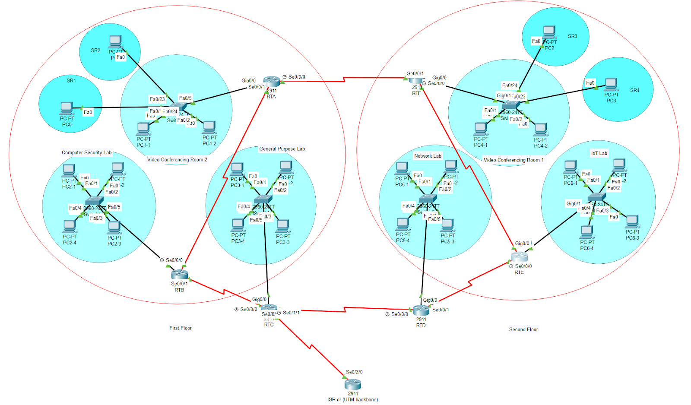

#### Figure 5.2 shows updated topology

**Switches’ vlans**

* VC2 Switch

#### Figure 5.2.1 shows VC2 switch

#### VC1 Switch

#### Figure 5.2.2 shows VC1 switch

#### Network Lab SwitchFigure 5.2.3 shows Network Lab Switch

#### IoT Lab Switch Figure 5.2.4 shows IoT Lab Switch

* General Purpose Lab Switch 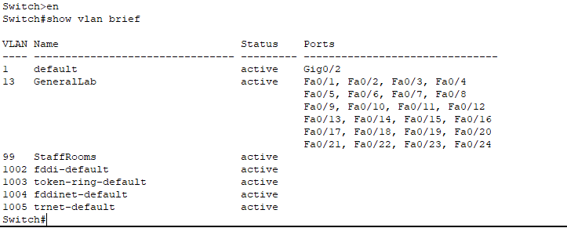

#### Figure 5.2.5 shows General Purpose Lab Switch

* Computer Security Lab 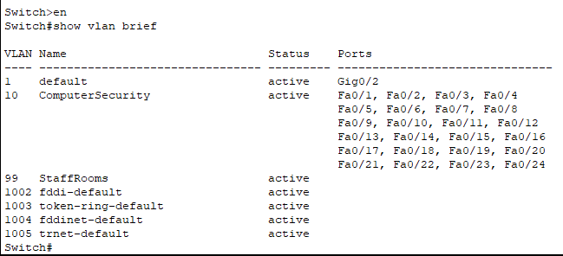

#### Figure 5.2.6 shows Computer Security Lab

**Routers’ Routing table**

* **RTA**

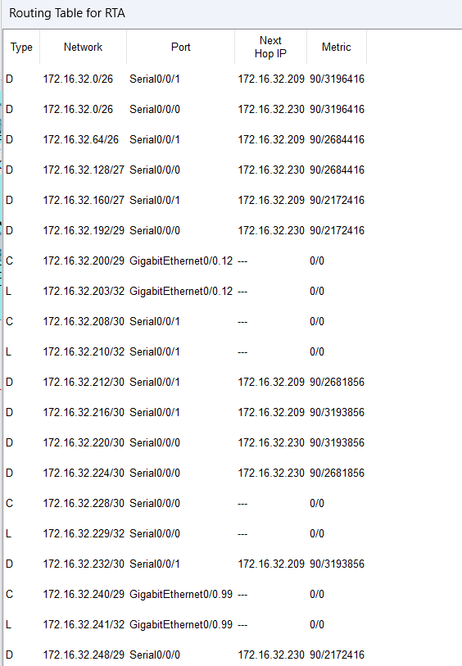

#### Figure 5.2.7 shows routing table of RTA

* **RTB**

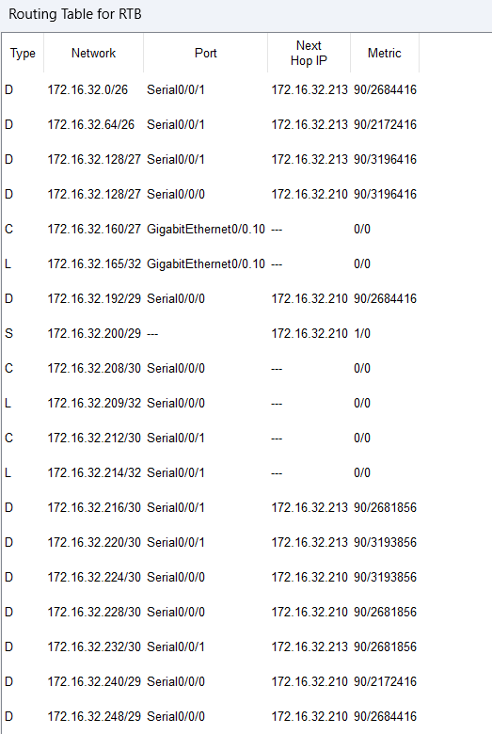

#### Figure 5.2.8 shows routing table of RTB

* **RTC**

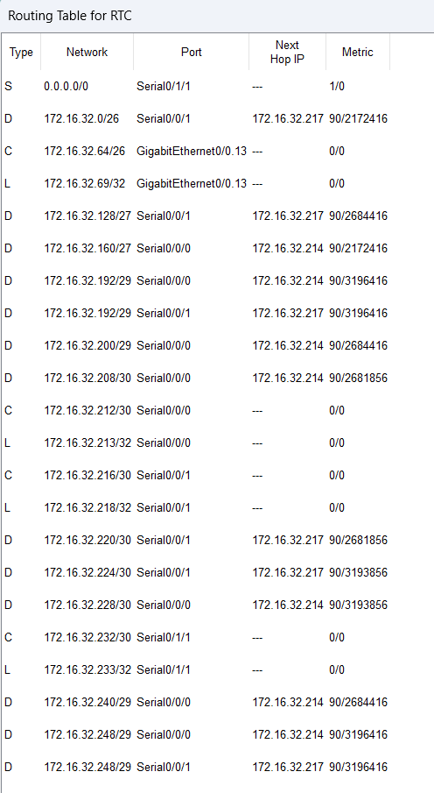

Figure 5.2.9 shows routing table of RTC

* **RTD**

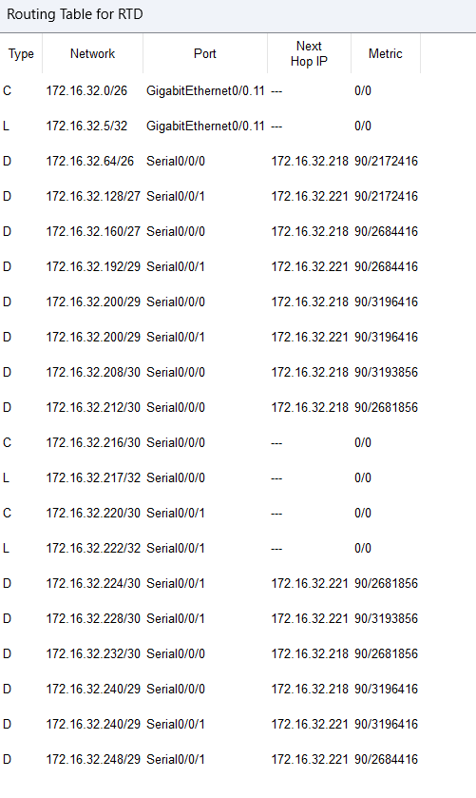

#### Figure 5.2.10 shows routing table of RTD

* **RTE  
  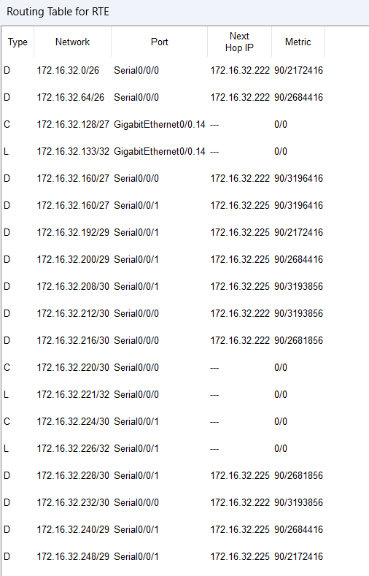**

#### Figure 5.2.11 shows routing table of RTE

* **RTF  
  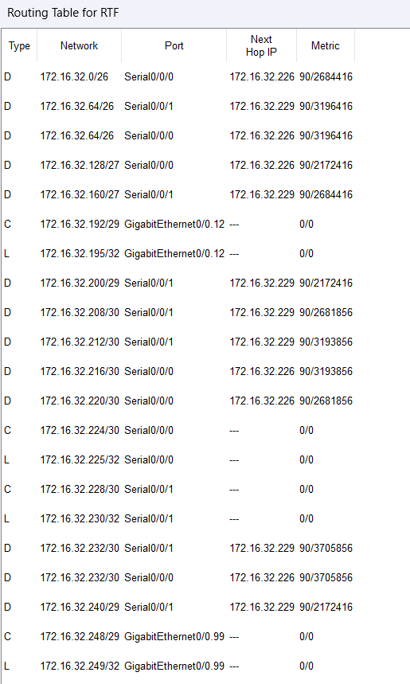**

#### Figure 5.2.12 shows routing table of RTF

### REFLECTION

In task 5, we implemented VLAN in our network. Since we had to add two more staff rooms, subnetting proceeded further to cater the new requirement. Apart from that, we assigned interfaces to VLANs to make their own private accessibility. The VLANs implementations were done well. In order to make this better we think we should have considered the size and scope of VLANs. It is advisable to keep VLANs small and focused, with a limited number of devices and users. This approach enhances network performance by reducing the amount of broadcast traffic and improves security by limiting the potential impact of security breaches or network failures within a specific VLAN.

## Task 6

**UPDATED TOPOLOGY**

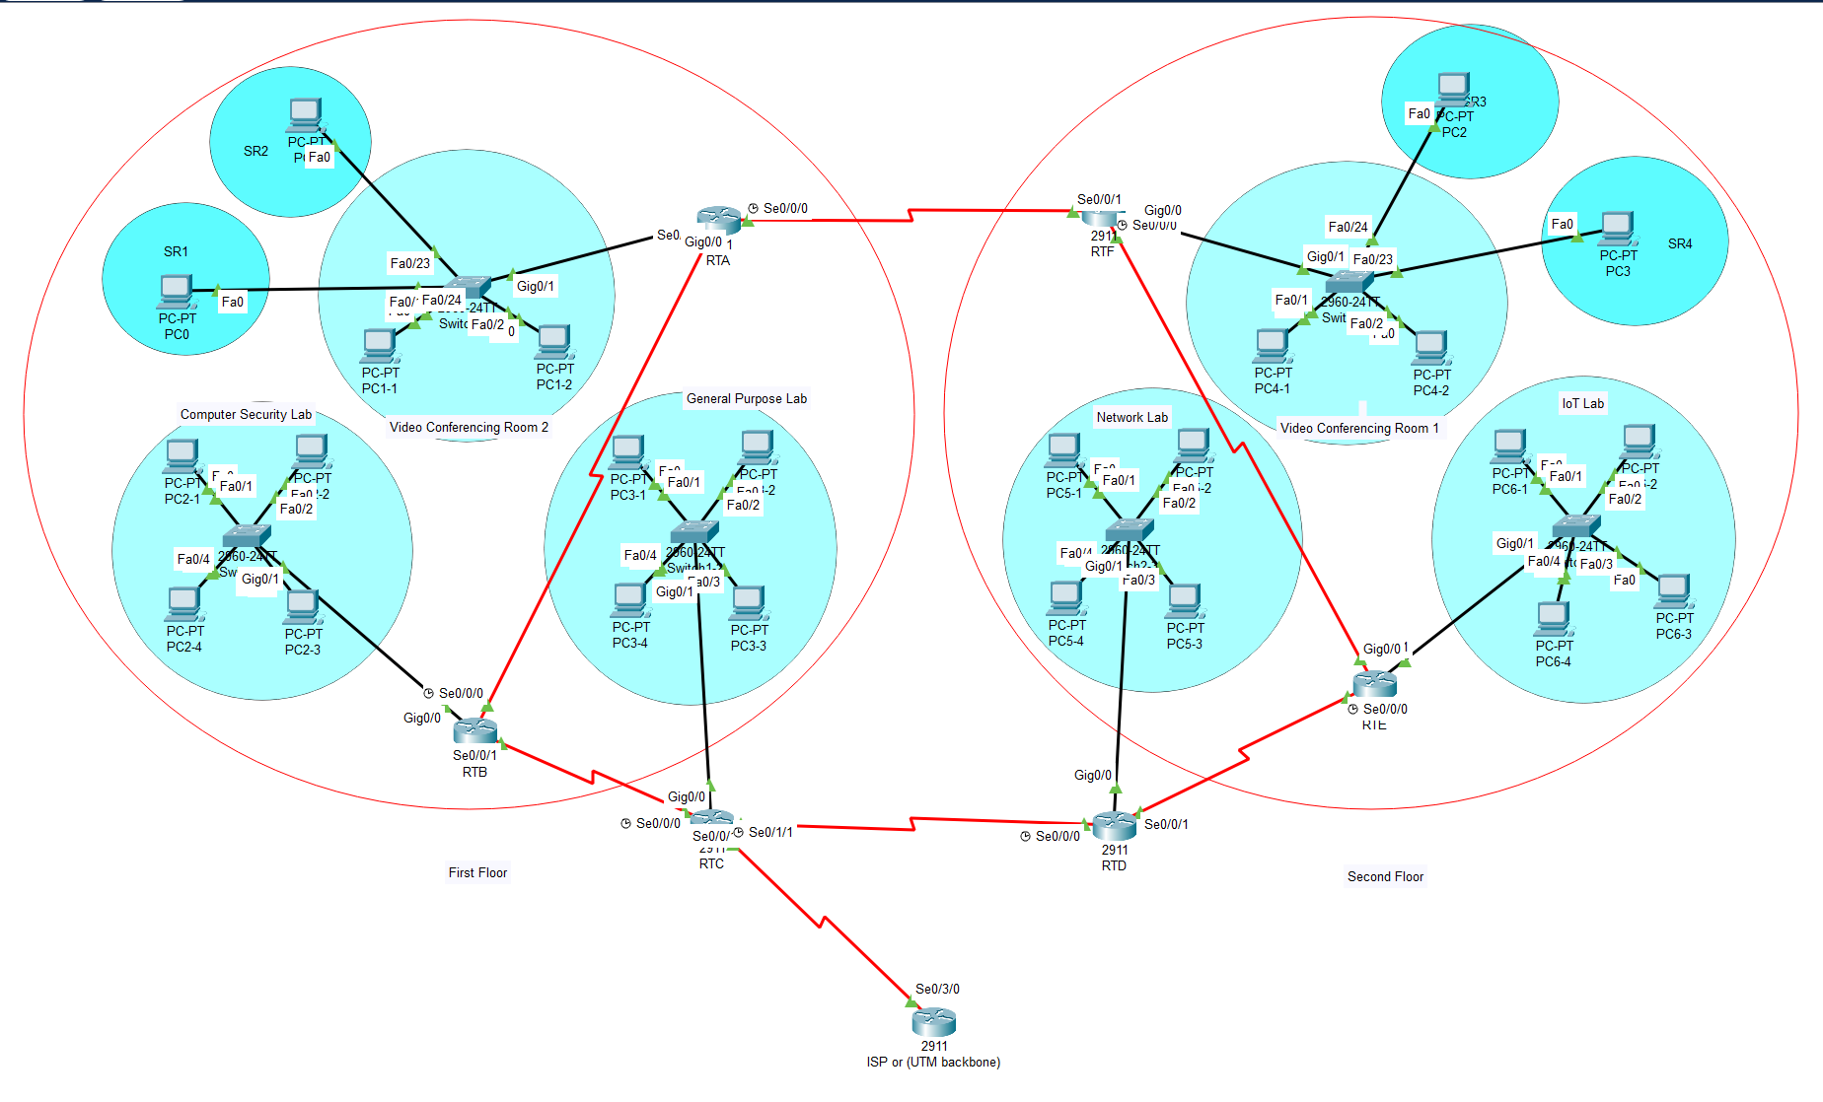

#### Figure 6.1 shows updated topology

In our Topology we’ve used RTD as DHCPv4 server, thus both its interfaces work as helpers for other relay agents inside the topology.

### CONFIGURATIONS ON IMPLEMENTING DHCPV4 SERVER

Network Lab :

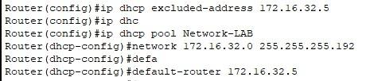

#### Figure 6.1.1 shows configuration on Network Lab

IOT Lab:

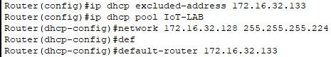

#### Figure 6.1.2 shows configuration on IoT Lab

VC1 and SRF2

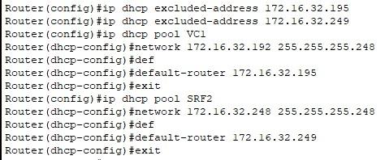

#### Figure 6.1.3 shows configuration on VCI and SRF2

General Lab:

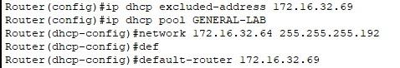

#### Figure 6.1.4 shows configuration on General Lab

Computer Security Lab:

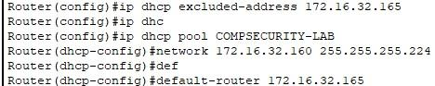

#### Figure 6.1.5 shows configuration on Computer Securiy Lab

VC2 and SRF1:

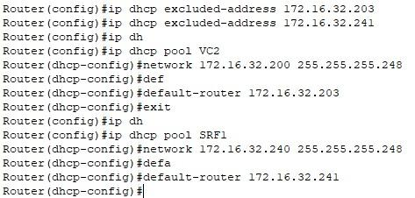

#### Figure 6.1.6 shows configuration on VC2 and SRF1

### 

### 

### 

### CONFIGURING THE RELAY AGENT

RTA:

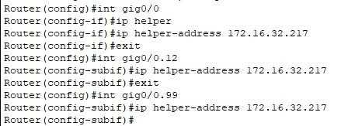

#### Figure 6.2.1 shows configuration on RTA

RTB:

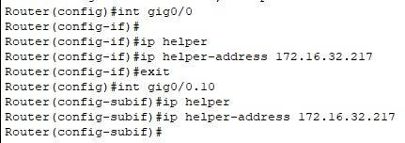

#### Figure 6.2.2 shows configuration on RTB

RTC:

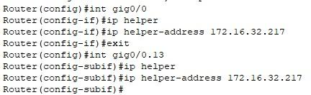

#### Figure 6.2.3 shows configuration on RTC

RTF:

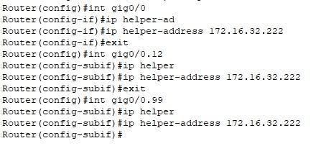

#### Figure 6.2.4 shows configuration on RTF

RTE:

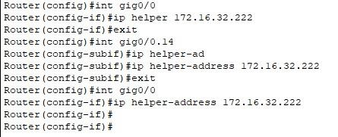

#### Figure 6.2.5 shows configuration on RTE

### DHCP REQUEST

RTA:

1. VC2_PC1-2

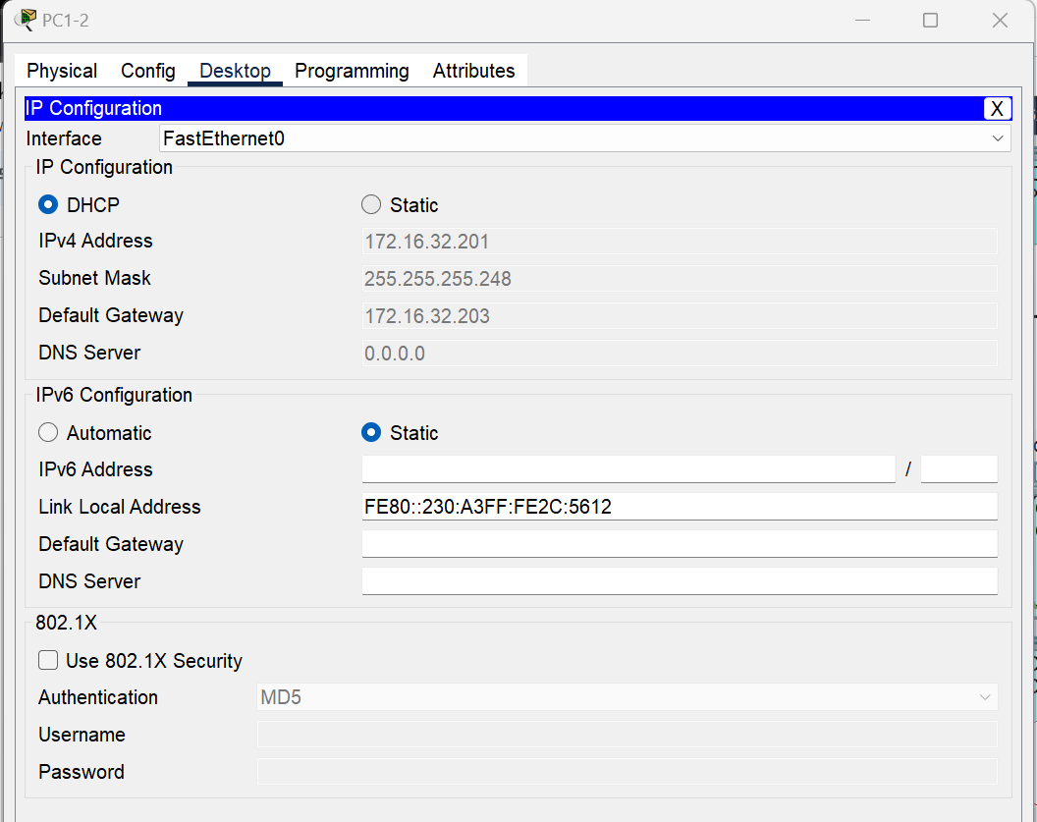

#### Figure 6.3.1.1 shows DHCP request on VC2_PC1-2

1. SR1_PC1

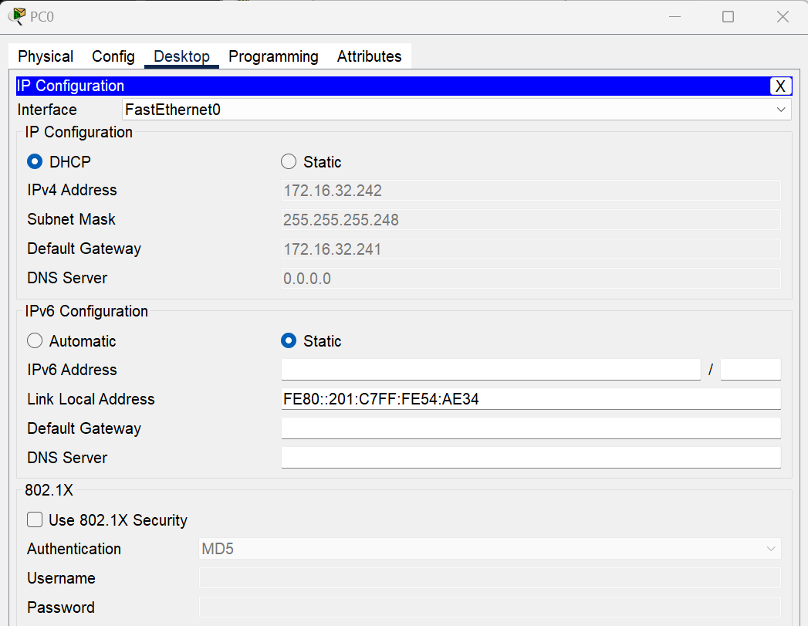

#### Figure 6.3.1.1 shows DHCP request on SR1_PC1

RTF:

1. VC2_PC4-1

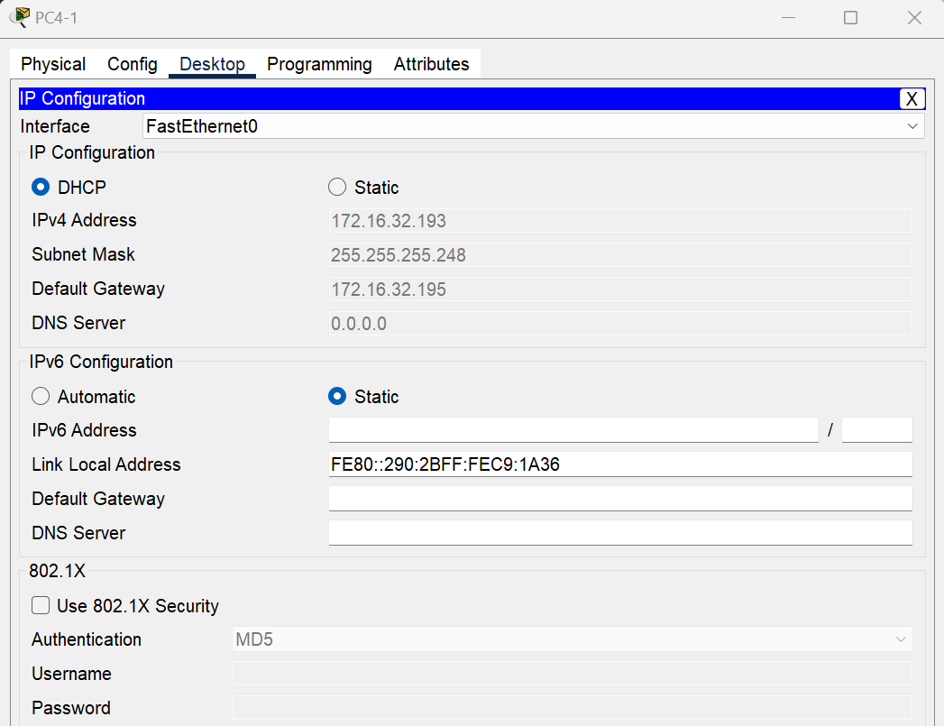

#### Figure 6.3.2.1 shows DHCP request on VC2_PC4-1

1. SR4_PC3

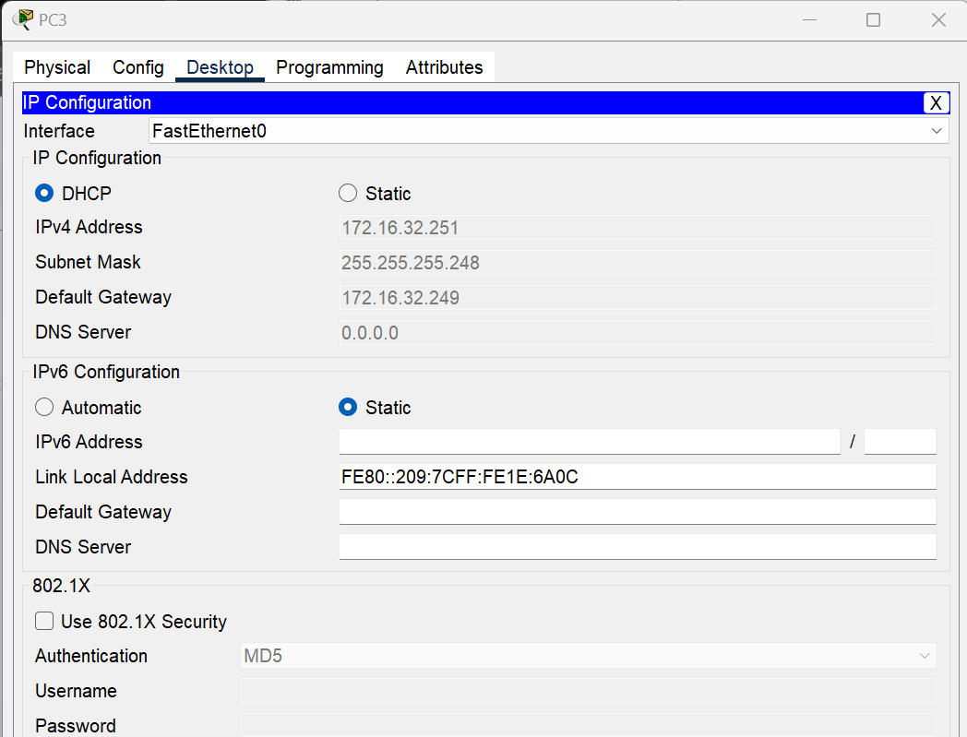

#### Figure 6.3.1.1 shows DHCP request on SR4_PC3

### REFLECTION

In task 6, we implemented DHCP in our network. As we already assigned individual rooms/labs to its own VLANs, configuring DHCP on servers and configuring the relay agent were done perfectly. We ensured that the end hosts get their IP address without manually assigning but dynamically from the server. To make this even better we could have considered security by implementing DHCP snooping and DHCP server authentication. DHCP snooping helps prevent unauthorized DHCP servers from distributing IP addresses and protects against rogue DHCP servers. DHCP server authentication ensures that only trusted DHCP servers can provide IP address assignments, mitigating the risk of malicious activities or unauthorized IP address conflicts.

# Conclusion

In conclusion, the project to build and configure the network for the Faculty of Computing (FC) at UTM University's new two-story building has been successfully executed. We have designed and implemented a network infrastructure that meets the needs of FC users, including staff and students. Throughout the project, our focus has been on scalability, simplicity, performance, and security.

By carefully considering each action and conducting thorough research, we have ensured a smooth execution of the project. We have utilized the Packet Tracer simulation app to create a realistic network environment, connecting the various labs, video conferencing rooms, and staff rooms with appropriate devices and cables.

Throughout the project, we have kept the end-user experience in mind, striving to provide a user-friendly and easily manageable network setup. The completion of the group report, reflecting on our work and providing suggestions for improvement, ensures that we have a comprehensive overview of the project's implementation and can make future enhancements.

Overall, this project has not only allowed us to apply our theoretical knowledge in a real-world context but has also provided us with valuable insights into network design, configuration, and management. The successful implementation of the network infrastructure for the FC building sets the foundation for a reliable, secure, and efficient computing environment for the faculty and its users.

# Team responsibilities

| **Task / Member** | **Mohammed**  **Hussein** | **PRAVIN SIVANATHAN** | **ABDUL AZIM** | **SADIK AL MAHMUD** |
| --- | --- | --- | --- | --- |
| **T1** | Since task 1 was not complicated and there were few things only to do, thus we’ve divided the floor plan design and updating for Hussein and Sadik. Meanwhile, Azim and Pravin have done the reporting part for that task. | | | |
| **T2** | * Doing and creating the Packet Tracer topology | | * Doing and finalizing the report and meeting minutes | |
| **T3** | * Dividing, calculating and arranging the subnets for each lab | | * Doing and finalizing the report and meeting minutes | |
| **T4** | * Prepare the report and screenshots for the routing tables and pings | * Do the routing algorithms and apply them inside the pkt file | * Finalizing the report and meeting minutes | |
| **T5** | * Configure the VLANs in switches and router in the topology | * Translate the topology from the pkt file to the report, while also helping doing the VLANs | * Translate the topology from the pkt file to the report, while also helping doing the VLANs * Finalizing the report | - |
| **T6** | * Do the DHCP configurations for all the topology and finalize the pkt file | * Export all the routing tables and ping results to the report while doing it as well | * Finalizing the report and meeting minutes | - |
| **T7** | * Abstract, Introduction, Conclusion and appendices | * Compiled Tasks from 1 to 7 | * Title page, table of content, table of figures | - |

**Reference**

1. **Websites:**
2. Cisco Networking Academy. (n.d.). https://www.netacad.com/
3. Cisco Learning Network. (n.d.). https://learningnetwork.cisco.com/s/packet-tracer-alternative-lab-solutions
4. Cisco Networking Academy. (n.d.). https://www.netacad.com/
5. *Free CCNA tutorials. study CCNA for free!*. Study CCNA. (2022, December 17). https://study-ccna.com/
6. Networkcomputing.com. (n.d.). https://www.networkcomputing.com/

**B. Books:**

1. Forouzan, B. A., & Fegan, S. C. (2018). Data Communications and Networking (6th ed.). McGraw-Hill Education.
2. Peterson, L. L., & Davie, B. S. (2012). Computer Networks: A Systems Approach (5th ed.). Morgan Kaufmann.
3. Beasley, J., & Miller, P. (2012). Modern Routing Protocols: OSPF, EIGRP, BGP, and MPLS Concepts and Configuration (2nd ed.). Cisco Press.

**Appendices**

Meeting minutes 1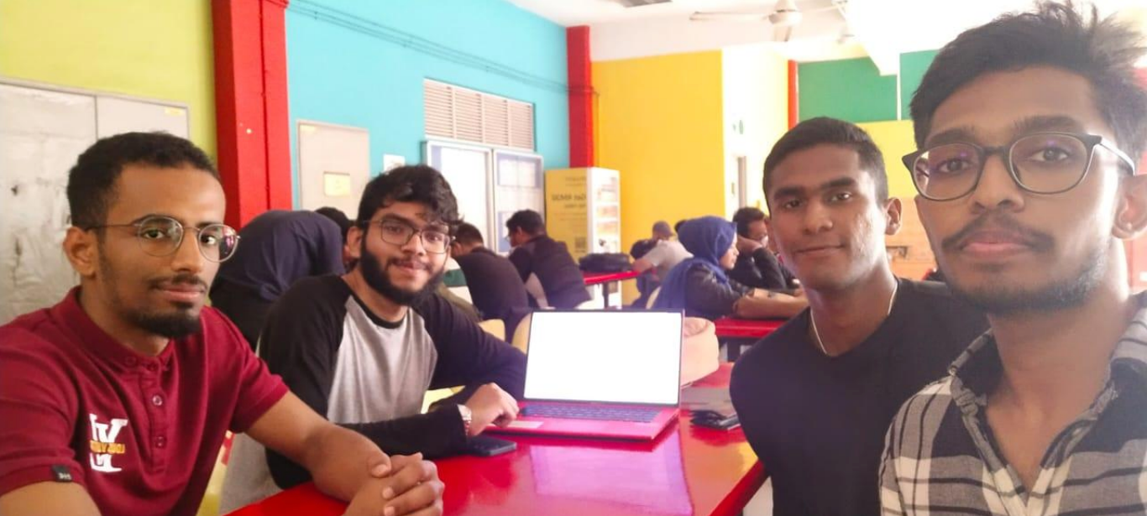

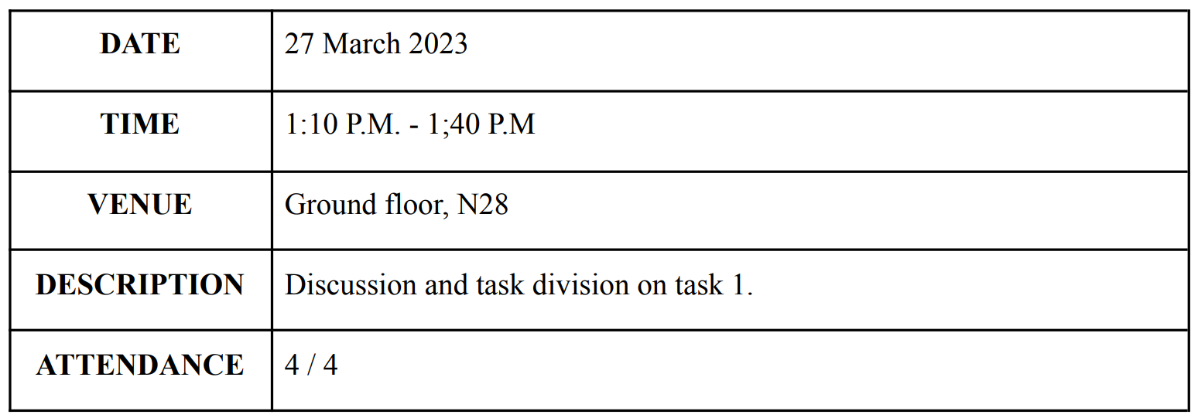

Meeting minutes 2

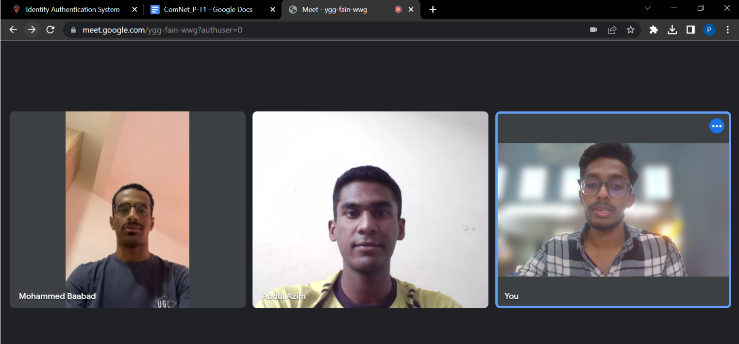

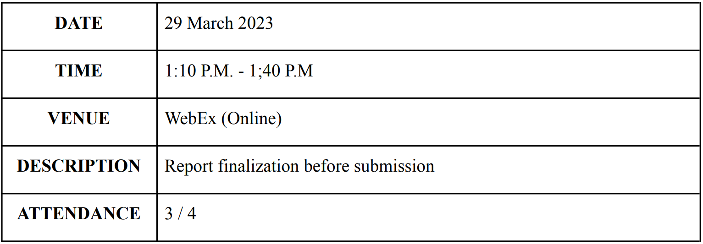

Meeting minutes 3

Date: 05/04/2023   
Time: 10:40 PM - 11:40 PM   
Platform: Google meet

Members:

| **NAME** | **MATRICS NUM** |
| --- | --- |
| PRAVIN SIVANATHAN | A21EC0123 |
| SADIK AL MAHMUD | A20EC4049 |
| ABDUL AZIM BIN ANUAR VEERA | A21EC0001 |
| MOHAMMED HUSSEIN SALEH BA ABBAD | A21EC4015 |

Meeting Agenda/Purpose:

| **Time** | **Meeting Agenda/Purpose** |
| --- | --- |
| 10:40PM | Deciding how we could divide the tasks for each member and the basic stuff about Packet Tracer. |
| 11:20 PM | Discussing the devices needed in the topology and how to connect them to each other. |
| 11:40 PM | Meeting ends. |

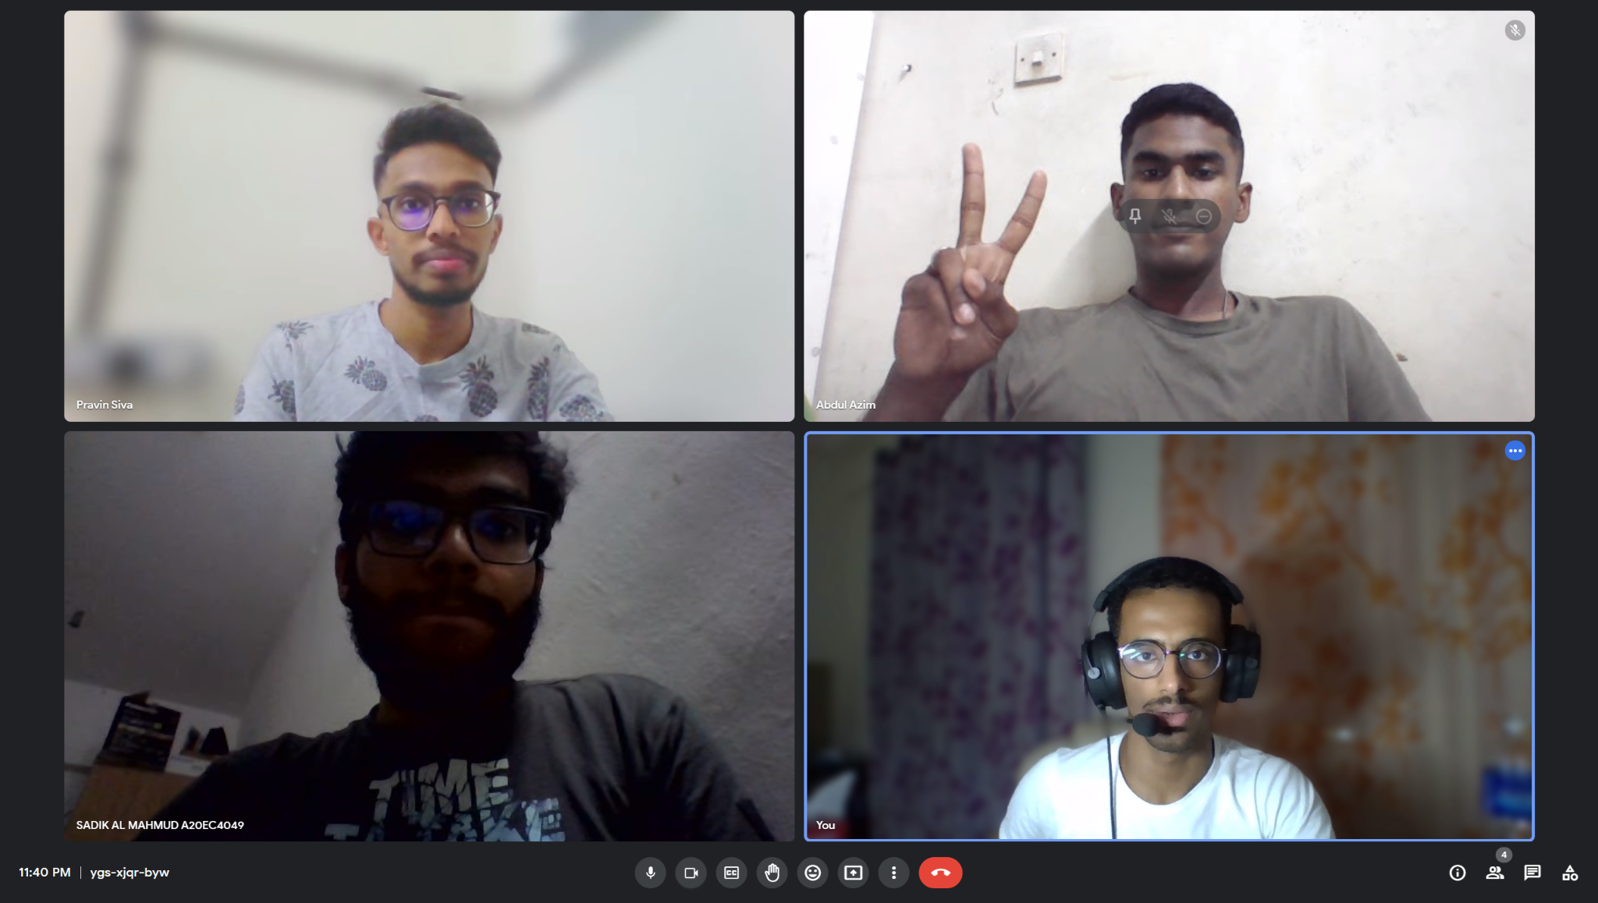

Meeting minutes 4

Date: 06/04/2023   
Time: 4:40 PM - 5:40 PM   
Platform: Google meet

Members:

| **NAME** | **MATRICS NUM** |
| --- | --- |
| PRAVIN SIVANATHAN | A21EC0123 |
| SADIK AL MAHMUD | A20EC4049 |
| ABDUL AZIM BIN ANUAR VEERA | A21EC0001 |
| MOHAMMED HUSSEIN SALEH BA ABBAD | A21EC4015 |

Meeting Agenda/Purpose:

| **Time** | **Meeting Agenda/Purpose** |
| --- | --- |
| 4:40PM | Each member shows what he has done for the task. |
| 5:20 PM | Discussing and finalizing the topology as well as correcting the mistakes. |
| 5:40 PM | Meeting ends. |

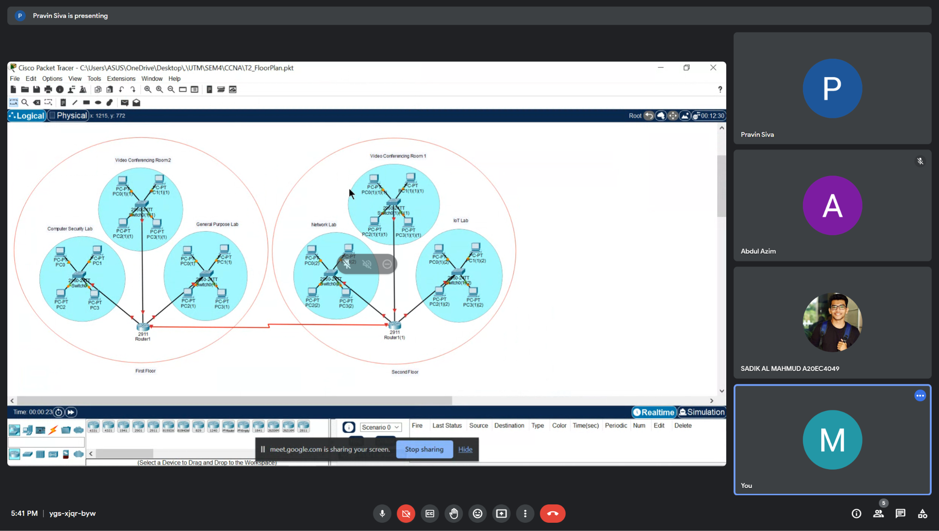

Meeting minutes 5

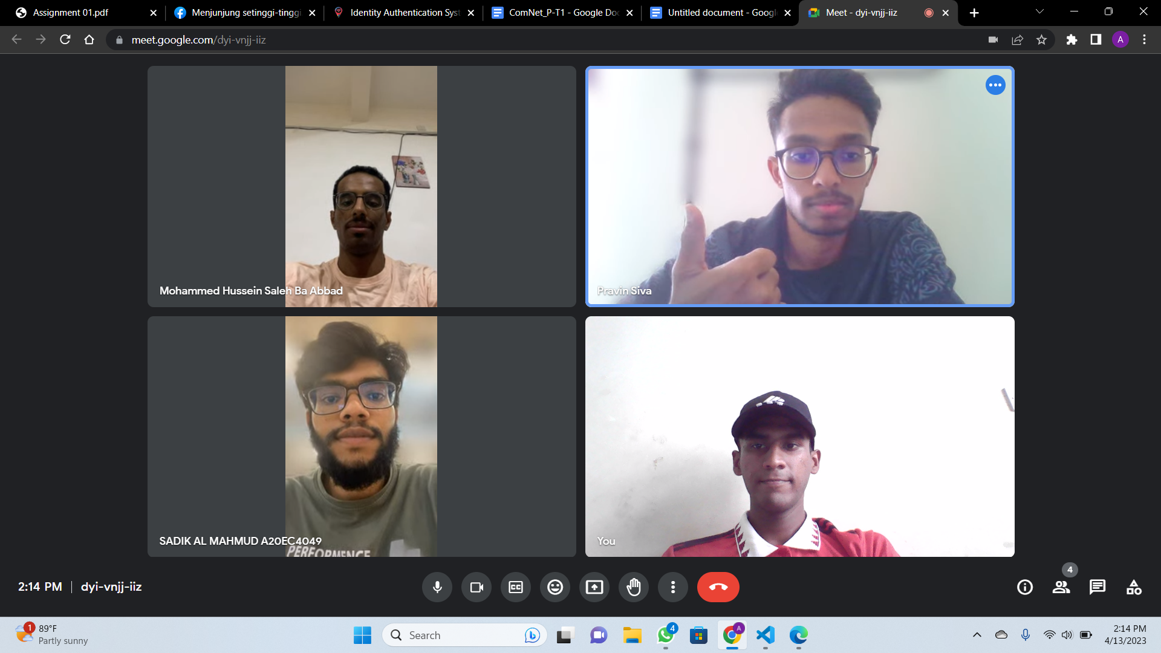

| **DATE** | 08 April 2023 |
| --- | --- |
| **TIME** | 2:15 pm - 2:30 pm |
| **VENUE** | Google meet |
| **DESCRIPTION** | Dividing task for subnetting  Pravin - Subnetting for IoT Lab and VC 1  Azim - Subnetting for Network Lab  Mohommad - Subnneting for Computer Security Lab and VC2  Sadik - Subnetting for General Purpose Lab |
| **ATTENDANCE** | 4 / 4 |

Meeting minutes 6

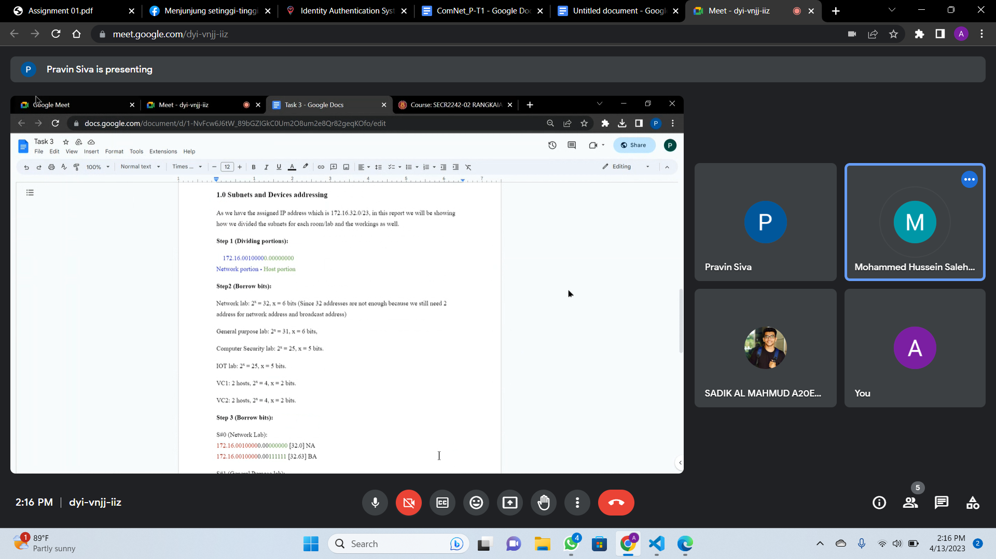

| **DATE** | 13 April 2023 |
| --- | --- |
| **TIME** | 2:00 pm - 2:40 pm |
| **VENUE** | Google meet |
| **DESCRIPTION** | Checking for errors and mistakes of the completed work by each team member. |
| **ATTENDANCE** | 4 / 4 |

Meeting minutes 7

| **DATE** | 22 May 2023 |
| --- | --- |
| **TIME** | 2:15pm-2:30pm |
| **VENUE** | Google meet |
| **DESCRIPTION** | Dividing task for each member:  Pravin - Doing routing protocols  Azim - Configuring the routers, switches and PCs in the topology  Mohommad Hussein - Redesign the topology, so it suits more than one routing protocol and do the subnetting needed between new routers.  Sadik - Doing the Routing Table and Appendix |
| **ATTENDANCE** | 4 / 4 |

Minute Meetings 8

| **DATE** | 26 May 2023 |
| --- | --- |
| **TIME** | 3:15pm-4:00pm |
| **VENUE** | Google meet |
| **DESCRIPTION** | Finalize the workings for each individual while checking and correcting all mistakes that have been done in the Packet Tracer file.  Doing the report and finalizing it. |
| **ATTENDANCE** | 4 / 4 |

Minute Meetings 9

| **DATE** | 09 June 2023 |
| --- | --- |
| **TIME** | 4:15pm-5:30pm |
| **VENUE** | Google meet |
| **DESCRIPTION** | Dividing task for subnetting  Pravin - Redesign topology in the packet tracer  Azim - Subnetting for staff rooms  Mohammed - Configure VLANs |
| **ATTENDANCE** | 3/3 |

Minute Meetings 10

| **DATE** | 23 June 2023 |
| --- | --- |
| **TIME** | 2:00 PM - 4:00 PM |
| **VENUE** | Google meet |
| **OBJECTIVE** | 1. Read the task 5 questions and understand the needs.  2. Update the topology by adding staff rooms.  3. Update the addressing table and subnetting calculations.  4. Distribute each lab for each member to update. |
| **ATTENDANCE** | 3/3 |

Meeting minutes 11

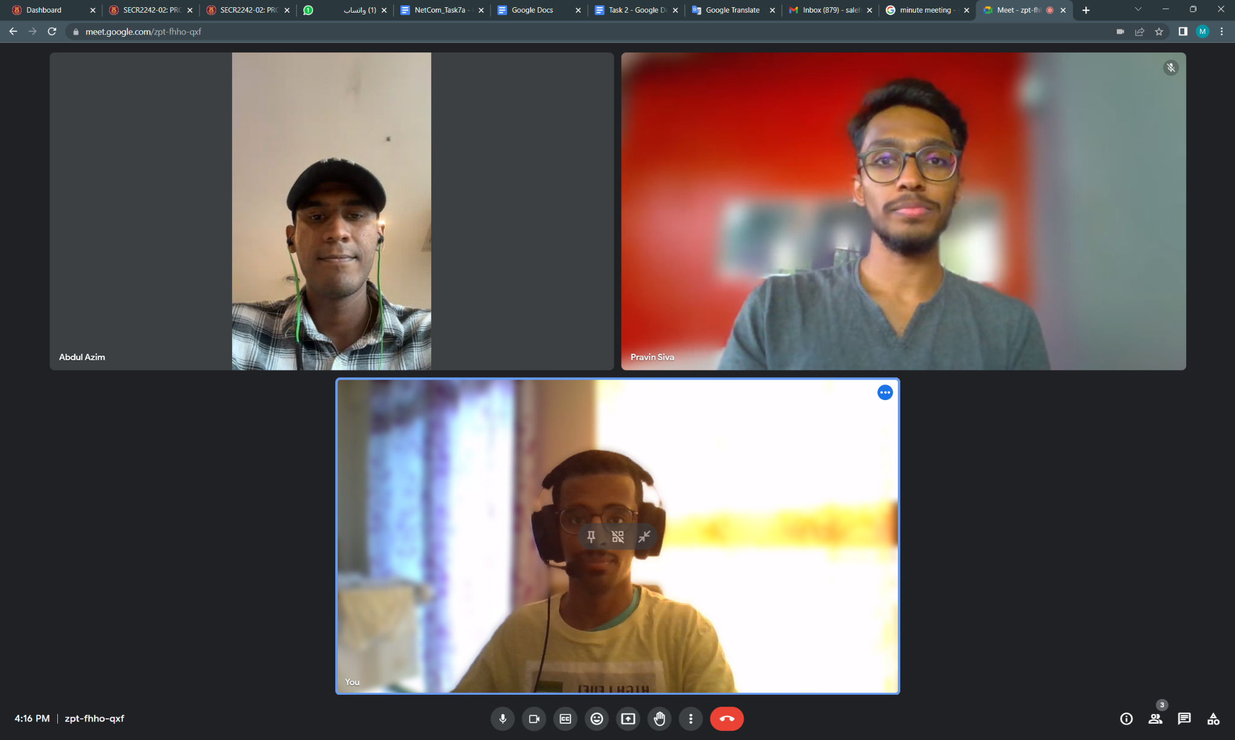

| **DATE** | 29 June 2023 |
| --- | --- |
| **TIME** | 2:00 PM - 4:00 PM |
| **VENUE** | Google meet |
| **OBJECTIVE** | * Distribute the group working and dividing the tasks for task 7a between the members. * Review the previous tasks for any changes or updates |
| **ATTENDANCE** | 3/3 |

Meeting minutes 12

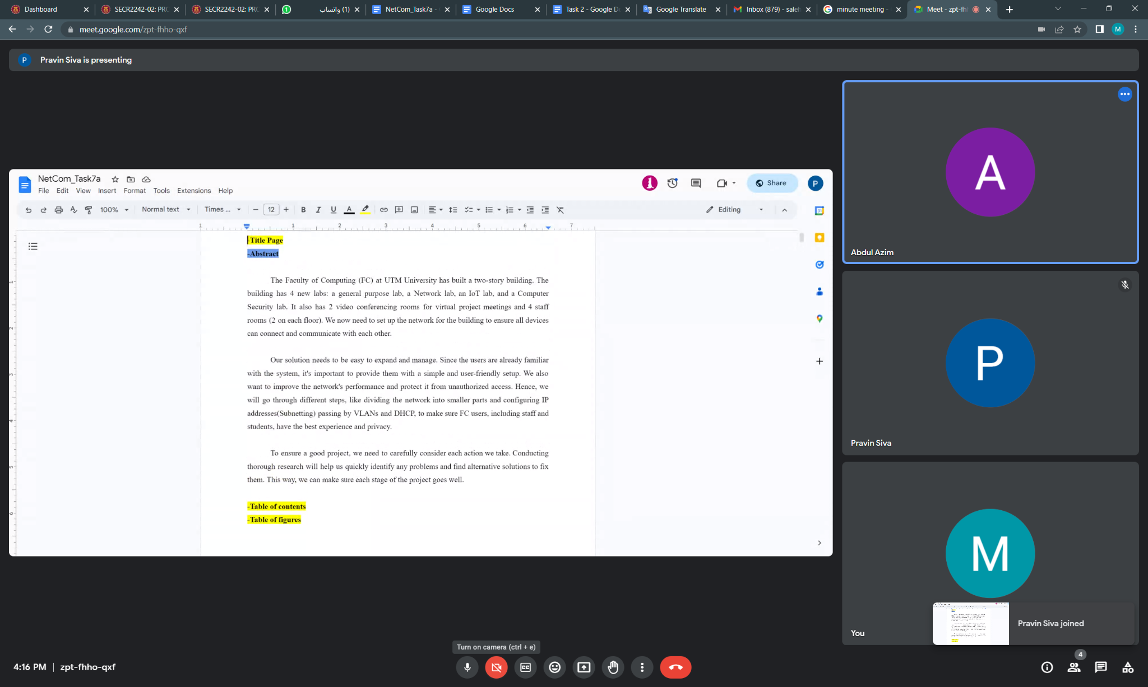

| **DATE** | 1 July 2023 |
| --- | --- |
| **TIME** | 2:30 PM - 4:15 PM |
| **VENUE** | Google meet |
| **OBJECTIVE** | * Review the last task and check everyones working * Finalize the reports and pkt file |
| **ATTENDANCE** | 3/3 |